1. **Machine Learning Definition and Function Approximation**:
   * Machine learning allows computers to learn from data.
   * In traditional statistical modeling, we choose a model that approximates the underlying process.
   * In machine learning, we often know less about the underlying process or it's too complicated, so we approximate the equation from the data.
   * Function approximation enables future values to be predicted using machine learning.
2. **Definition of Machine Learning**:
   * Machine learning falls within the broader category of artificial intelligence.
   * There are four quadrants describing subsets of artificial intelligence, focusing on machines' ability to think and act, and whether they replicate human or rational behavior.
   * Machine learning focuses more on honing in on the thought processes.
   * The outcome of machine learning depends on whether we're trying to think specifically in human terms or rationally.
3. **Machine Learning and Learning**:
   * Machine learning falls into the subset of artificial intelligence where machines are able to learn.
   * Learning is the root from which machines can make decisions, solve problems, perceive, reason, and act.
4. **Definition of a Model**:
   * A model is a simplified representation of a larger reality.
   * A good model omits unimportant details while retaining what's important.
   * Choosing the right model reduces complexity while preserving important features or relationships.
5. **Applications of Machine Learning in Daily Life**:
   * Examples include spam filtering, web search ranking, optimizing mail routes, fraud detection, movie recommendations, etc.
   * Machine learning is pervasive in everyday life and continues to expand its influence.

These points provide an overview of supervised machine learning, its definition, applications, and the principles underlying it.

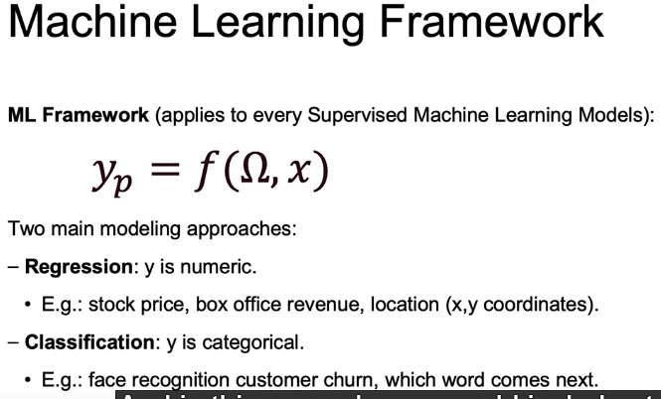

Here are the key points extracted from the passage regarding the difference between parameters and hyperparameters:

1. **Fit Parameters**:
   * Fit parameters are aspects of the model that are estimated using the data.
   * Examples include linear regression coefficients.
2. **Hyperparameters**:
   * Hyperparameters are decisions made about the model itself before fitting it to the data.
   * These decisions lead to how hyperparameters are determined.
   * Tweaking hyperparameters allows for optimizing the model's power, and they are not directly learned by the model itself.
3. **Supervised Learning Categories**:
   * Supervised learning is split into two categories based on the outcome variable being predicted: regression and classification.
   * Regression predicts numeric values (e.g., stock prices, box office revenue).
   * Classification predicts categorical outcomes (e.g., face recognition, customer churn, word prediction).
4. **Supervised Machine Learning Framework**:
   * The supervised machine learning framework involves input (X), predicted output (Y), and a machine learning model that learns the parameters (Omega) to generate predictions based on X.
5. **Learning Parameters**:
   * Data scientists train the model to find the best parameters by looking at past data.
   * Each observation (X) relates to an outcome variable (Y), helping the model learn the parameters defining the relationship between features in X and outcome variables in Y.
6. **Updating Parameters**:
   * As new data comes in, parameters are updated using a loss function (J of Y and YP), which quantitatively measures how close predictions (YP) are to actual values (Y).
   * The update rule determines how to update parameters to minimize the loss function, i.e., minimize the error between predictions and actual values.

These points provide a clear distinction between parameters and hyperparameters in the context of supervised machine learning.

1. **Interpretation Objective**:
   * Focuses on understanding the mechanism of the model to find insights about the data.
   * Looks to parameters to provide insight into the system, identifying features that affect the outcome variable.
   * Common workflow involves gathering x and y data, training the model to learn parameters while focusing on interpretability.
   * May choose a less complex model for better interpretability, optimizing for high interpretability rather than high prediction power.
   * Examples include understanding customer demographics for loyalty, determining safety features to prevent accidents, and assessing the effect of marketing budget on movie revenue.
2. **Prediction Objective**:
   * Focuses on how well predictions will do compared to actual values without prioritizing interpretability.
   * Measures performance using quantitative metrics to assess the closeness between predicted values (y_p) and actual values (y).
   * Risk of using black box models increases, especially with more complex models like deep learning.
   * Examples include predicting customer churn or default, and predicting future purchases based on past purchase history.
3. **Trade-off Between Interpretation and Prediction**:
   * There's often a trade-off between models with high interpretability and those with high prediction power.
   * Businesses must choose between models based on their specific objectives, considering the balance between interpretability and prediction accuracy.

These points highlight the different approaches and trade-offs between interpretation and prediction objectives in supervised machine learning.

Here are the key points extracted from the passage regarding interpretation and prediction objectives within supervised machine learning:

1. **Example Dataset**:
   * The example dataset used is the housing dataset, with the target variable being the price of housing and features including characteristics about the house and area.
2. **Interpretation Objective**:
   * Focuses on understanding the factors affecting the target variable (housing price).
   * Parameters obtained from the model provide insight into feature importance.
   * Feature importance indicates the importance of each feature in predicting the target variable.
   * Examples include understanding the effect of house quality, living area, year built, etc., on housing prices.
3. **Prediction Objective**:
   * Focuses on generating the best predictions for the target variable.
   * Assessing the accuracy of predictions without focusing on interpretability.
   * Graphs such as predicted values vs. actual values are used to evaluate prediction accuracy.
   * Examples include accurately predicting housing prices without focusing on why certain features are important.
4. **Switch to Classification Problem**:
   * Switching from regression to classification, using the example of customer churn.
   * Target variable is whether a customer leaves the company, with features such as subscription costs, time as a customer, etc.
5. **Balancing Interpretation and Prediction**:
   * Most projects require a balance between interpretation and prediction.
   * Interpretability can provide insights into improving predictions, and vice versa.
   * Not all models support both interpretation and prediction equally; simpler models like linear regression are more interpretable, while complex models like deep learning may be less so.
6. **Machine Learning Objectives**:
   * Machine learning focuses on model-building to support interpretation and/or prediction goals.
   * Models use past data to build a useful model for future predictions.
   * The prediction equation involves learning parameters from input data to make predictions.
7. **Recap and Final Takeaways**:
   * Trade-off between interpretation and prediction needs to be considered in machine learning projects.
   * Examples demonstrate the application of interpretation and prediction objectives in different datasets (housing and churn).
   * Final takeaways include understanding the balance between interpretation and prediction and their importance in machine learning.

These points provide insights into the objectives and considerations regarding interpretation and prediction within supervised machine learning scenarios.

Here are the key points extracted from the passage regarding supervised machine learning, specifically regression and classification:

1. **Supervised Learning Overview**:
   * Supervised learning involves data with outcomes, where a specific model is used to predict the outcome variable based on input features.
   * During the fitting process, the model's parameters are tuned to optimize prediction accuracy.
   * Once the model is fitted, it can be used to predict outcomes for new data without known outcomes.
2. **Regression**:
   * Regression predicts a continuous outcome variable, such as box office revenue, housing prices, or the number of attendees.
   * Models are fitted using data with known continuous outcomes, and predictions are made for new data.
3. **Classification**:
   * Classification predicts a categorical outcome variable, such as customer churn, fraudulent charges, or political affiliation.
   * Models are fitted using data with known categorical outcomes, and predictions are made for new data.
4. **Example Applications**:
   * Regression example: Predicting movie revenue based on features like marketing budget and cast.
   * Classification example: Predicting whether emails are spam or not spam based on word features.
5. **Model Fitting Process**:
   * Models are fitted using known outcomes and input features.
   * Fitted models are then used to predict outcomes for new, unlabeled data.
6. **Requirements for Classification**:
   * Features must be quantifiable and may require encoding (e.g., one-hot encoding for word features).
   * Labeled data is needed for model training, which may require human labeling effort.
   * Similarity metrics are used to measure the similarity between new data and training data.
7. **Recap**:
   * The section covered the types of supervised learning (regression and classification) and provided examples to illustrate the model fitting and prediction process.
   * Once models are fitted with parameters, they can be used to predict outcomes for new, unlabeled data.

These points provide an overview of supervised learning, including regression and classification, and highlight the process of model fitting and prediction for both types of problems.

***Cross Validation***

1. **Importance of Data Splitting**:
   * Splitting data into training and test sets is crucial for machine learning model development.
   * By separating data into two distinct sets, one for training the model and the other for testing its performance, we mimic real-world scenarios where the model encounters unseen data.
   * This practice helps in evaluating the model's generalization ability and ensures that it performs well on new, unseen data.
2. **Learning Goals**:
   * The passage outlines the learning objectives related to data splitting, including understanding the process of dividing data into training and testing samples.
   * It emphasizes the importance of having a holdout set (or test set) to assess model performance on unseen data.
   * Additionally, it introduces the concept of cross-validation, which involves training and testing models on multiple different sets of data to ensure robustness and reliability.

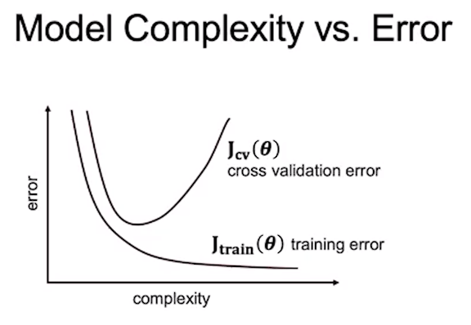

1. **Model Complexity vs. Error**:
   * Discusses the trade-off between model complexity and error.
   * As models become more complex, they may fit the training data better (reducing training error) but may generalize poorly to unseen data (increasing testing error).
   * Finding the right balance between model complexity and error is essential for building models that perform well on new data.
2. **Data Leakage**:
   * Data leakage refers to a situation where information from the test set inadvertently leaks into the training set, compromising the model's ability to generalize.
   * It emphasizes the importance of ensuring independence between training and test data to accurately evaluate model performance.
   * Strategies to prevent data leakage include proper data splitting techniques and awareness of potential sources of bias.
3. **Training Process**:
   * Describes the process of training a machine learning model using labeled training data.
   * This involves fitting a model to the training data to learn the optimal parameters that define the relationship between input features and the target variable.
   * The trained model is then used to make predictions on new, unseen data.
4. **Evaluation**:
   * Evaluating model performance involves comparing the model's predictions with the actual values in the test set.
   * Error metrics are used to quantify the disparity between predicted and actual values, providing insights into the model's accuracy and performance.
   * Common error metrics include mean squared error, mean absolute error, and accuracy for classification tasks.
5. **Syntax for Data Splitting in Python**:
   * Provides practical guidance on implementing data splitting in Python using the **train_test_split** function from the **sklearn.model_selection** module.
   * Explains how to specify the test size (either as a percentage or a numerical value) and handle features and outcome variables when splitting the data.
   * Demonstrates the syntax for splitting data into training and test sets, facilitating the application of these concepts in machine learning projects using Python and scikit-learn.

Top of Form

This passage provides a detailed explanation of the process of chaining multiple data processing steps together using pipeline functionality and performing cross-validation in machine learning using Python's scikit-learn library. Let's break down the key points and elaborate on them:

1. **Introduction to Notebook Content**:
   * The notebook aims to demonstrate the use of pipeline functionality and cross-validation techniques to streamline the machine learning workflow.
   * It mentions the use of **KFold** object for splitting data into multiple folds and using **cross_val_predict** and **GridSearchCV** for cross-validation.
2. **Library Imports**:
   * Various libraries are imported, including **model_selection** from scikit-learn for KFold and cross-validation functionalities, **linear_model** for linear regression, lasso, and ridge regression, **metrics** for performance evaluation metrics like R-squared, and **pipeline** for chaining data processing steps.
3. **Data Loading and Preparation**:
   * The dataset is loaded from a pickle file, which is a dictionary containing
   * The DataFrame contains features and target variables for a housing dataset, where the goal is to predict the median value of houses.
4. **Data Splitting with KFold**:
   * The process of splitting data into multiple folds using **KFold** is explained.
   * The **KFold** object is initiated with parameters like shuffle and number of splits to ensure randomness and exclusivity of test sets.
   * It demonstrates how **kf.split** generates a generator object with tuples containing train and test indices for each fold.
5. **Model Training and Evaluation in a Loop**:
   * Within a loop iterating over each fold, the data is split into training and test sets using the indices generated by **KFold**.
   * A linear regression model is fitted to the training data, and predictions are made on the test data.
   * The R-squared score is calculated to evaluate the performance of the model on each fold.
   * This process demonstrates how to train and evaluate models across multiple folds, highlighting the variability in performance across different test sets.
6. **Cross-Validation and Scaling**:
   * The passage hints at upcoming sections where additional steps like scaling will be added to the pipeline.
   * It mentions the use of **cross_val_predict** function for cross-validation, which will likely be explored further in subsequent sections of the notebook.
7. **Conclusion**:
   * The passage concludes by indicating the continuation of the notebook, where scaling and cross-validation techniques will be further explored.
   * It emphasizes the importance of cross-validation in assessing model performance and generalization.

Overall, this passage sets the stage for exploring advanced machine learning techniques, demonstrating how to chain preprocessing steps and perform cross-validation effectively using scikit-learn in Python.

1. **Introduction to Hyperparameter Tuning**:
   * the hyperparameter's to
   * be parts of our model that we as users will actually tune ourselves,
   * versus parameters, which will be learned by the model using machine learning.
   * Explanation of the difference between hyperparameters and parameters in a model.
   * Discussion on optimizing model performance by tuning hyperparameters using cross-validation.
2. **Introduction to geomspace**:
   * Overview of the **geomspace** function for generating sequences of numbers with geometric progression.
   * Example usage of **geomspace** to generate a sequence of values.
3. **Usage of geomspace for Hyperparameter Tuning**:
   * Demonstration of creating a sequence of alpha values for Lasso regression.
4. **Introduction to Lasso Regression**:
   * Overview of Lasso regression and its hyperparameter alpha.
   * Explanation of how alpha affects model complexity: higher alpha implies less complexity.
5. **Hyperparameter Tuning with Lasso Regression**:
   * Initialization of empty lists for scores and coefficients.
   * Iterating through different alpha values and fitting Lasso regression models.
   * Explanation of the need for scaling data before fitting Lasso regression.
   * Utilization of **cross_val_predict** for cross-validation and appending scores to the list.
   * Analysis of scores for different alpha values to determine optimal complexity.
6. **Visualizing Trade-off between Complexity and Error**:
   * Plotting the relationship between alpha values and model scores.
7. **Adding Polynomial Features to the Pipeline**:
   * Introduction to adding polynomial features to the pipeline.
   * Discussion on the order of operations within the pipeline and reasons for adding polynomial features before scaling.
8. **Hyperparameter Tuning with Polynomial Features**:
   * Initialization of lists for scores and alphas.
   * Similar process of iterating through alpha values and fitting Lasso regression models with polynomial features.
   * Explanation of warnings about max iterations and interpretation of scores.
9. **Selecting the Best Model**:
   * Selection of the best estimator based on the optimal alpha value.
   * Fitting the final model using the best estimator.
   * Examination of model performance and coefficients.
10. **Conclusion and Teaser for Ridge Regression**:
    * Conclusion of the hyperparameter tuning section.
    * Mention of exploring Ridge regression in the next section.

This breakdown covers all the key points discussed in Part 2 of the tutorial, detailing the process of hyperparameter tuning with Lasso regression, adding polynomial features to the pipeline, and selecting the best model based on cross-validation scores.

Top of Form

Top of Form